STEREO HEADSET
DH-440-USB
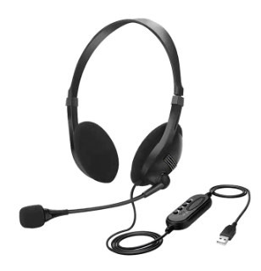

Descrption:
The DH-440-USB Stereo Headphone with microphone system, uses ClearSound audio technology to give high audio quality and is the perfect lightweight headset for home, travel ,business, education and gaming.

The DH-440-USB comes with large, cushioned ear cups attached to durable ergonomic adjustable headband designed to provide comfort during extended use.

With its built-in adjustable Microphone for Internet Video Conferencing Applications, this premium Stereo Headset provides great performance coupled with great value.

Features:
  - Speaker diameter : Ф40mm
  - Speaker Sensitivity : 105dB±3dB
  - Speaker Impedance : 32Ω
  - Speaker Frequency response : 20Hz - 20KHz
  - Rated Power : 100mW
  - Microphone Specification : 6*5mmDia.Electret condenser
  - Microphone Sensitivity : -58dB ±2dB
  - Microphone Directivity : Omni directional
  - Plug Type : USB
  - Cable length : Approx.2.0m±0.3m

